Geotechnical Engineering, Vol. 6, 1975

A CRITICAL RE-APPRAISAL OF THE INCREMENTAL STRESS-STRAIN THEORY FOR NORMALLY CONSOLIDATED . CLAYS

A.S. BALASUBRAMANIAM*

SYNOPSIS

The incremental stress-strain theory of RoscoE & PooROOSHASB (1963) is presented (in a slightly different form) with respect to shear strains. A comprehensive series of stress-con trolled triaxial tests was carried out and the results were compared with the predictions of the theory. The stress ratio-shear strain relationship of normally consolidated specimens sheared under undrained condition was unique and was independent of the consolidation pressure. Als.o, provided that the effect of the initial one-dimensional conso'lidation stress is
absent, the state boundary surface is unique for all types of tests including anisotropic con-
solidation. During anisotropic consolidation, the strain increment ratio was a constant and the void ratio varied linearly with the logarithm of the mean normal stress (the slope of the line is the same as that for isotropic consolidation). The volumetric strains in all typs of tests on normally consolidated clays may be successfully predicted from the state boundary surface as obtained from undrained tests. However, the shear strains may only be pre dicted for paths in which the stress ratio increases or remains constant.

INTROPUCTION

This paper is concerned with a critical re-appraisal of the incremental stress-strain theory for normally consolidated clays developed by RoscoE & PooROOSHASB (1963). The basic assumptions made in the theory are examin ed, and the predictions from the theory are compared with experimental ob servations from a large number of stress controlled triaxial tests in which the specimens were subject.ed to a variety of applied stress paths.
Several stress-strain theories have recently been developed to describe the stress-strain behaviour of normally consolidated clays; see RoscoE, ScHo FIELD & THURAIRAJAH (1963), ROSCOE & BURLAND (1968) and SCHOFIELD & WROTH (1968). In these theories, a fully saturated normally consolidated clay is assumed to behave as an elastic-plastic material. Based on this assump tiop, concepts such as yield surface and normality were used to obtain an ex pression for the strain increment ratio in terms of the stresses. · This expres sion was combined with an independent relationship for the strain increment ratio obtained, from an energy balance equation. Thus, a stress-strain

*Associate Professor of Geotechnical Engineering, Asian Institute of Technology, Bangkok, Thailand.
Discussion on this paper is open until 1 May 1976.
A.S. BALASUBRAMANIAM

theory for the prediction of strains in normally consolidated clays was deve loped. BALASUBRAMANIAM (1969), has shown that for stress paths with in creasing stress ratios these theories which are based on some of the concepts of plasticity theory and on an energy equation are mathematically similar (and in some case identical) to the incremental stress-strain theory of RoscoE & POOROOSHASB (1963). It therefore appears that the ROSCOE & POOROOSHASB's theory is more fundamental and should be examined critically for its precise validity.
In deriving the incremental stress-strain theory, RoscoE & PooROOSHASB (1963) assumed a unique state boundary surface for normally consolidated clays. The state boundary surface in the p, q, e space (where p is the mean normal stress, q is the deviator stress and e is the void ratio) is a surface con fining a space between itself and the origin within which a point can represent a state of an element of soil, but outside of which a point cannot represent such a state. The uniqueness of the state boundary surface will also be examined.
Experimental evidence will be presented to illustrate that the state path followed during anisotropic consolidation (i.e. consolidation with constant stress ratio) does lie on the state boundary surface obtained from undrained stress paths. The variation of strains and void ratios during anisotropic consolidation will also be studied. Finally, for the prediction of strains, the basic hypothesis that any applied stress path on the state boundary surface can be considered as an infinite number of small steps of undrained stress paths and anisotropic consolidation paths, will be examined for a large variety of applied stress paths.

Stress and Strain Parameters

The stress parameters used in the analysis of triaxial test results are :
p = (cr/ + 2cr/)/3 and q = (cr1'- cr3')
(Note that in the triaxial test cr2 ' = cr/)

where cr 1' , cr2 ' and cr/ are the principal effective compressive stresses. In terms of the principal compressive strains, E 1, E2 and E 3, the relevant strain parameters for use under the axi-symmetric conditions of the triaxial test (E2 = E3) are :
V = (E1 + 2 E3)
and E = 2(E 1 - E3)/3,
16
INCREMENTAL STRESS STRAIN THEORY

The axial strain E1 is. defined as :
Lo
I
e, log (L./L) (Co.n;;pression being positive)

L
is the initial height and L, the current height.
L
0

The volumetric strain v is given by :

Vo

v = IVdV

= ·1og

( V0 ) (Compressi•On bem.

g posi.ti.ve)

v .
V0 is the initial volume and V, the current volume. Expressed in terms of void ratios·(e)

v = log

1 + eo )
(
l+e
-

where e0 is the void ratio of the sample at the end of isotropic consolidation.
In this paper, unless otherwise stated, v and E will be measured from the state
of the sample under isotropic stress conditions and just prior to shear.

MATERIAL TESTED, SAMPLE PREPARATION AND TESTING PROCEDURE

All specimens were prepared from air-dried Kao.lin (liquid limit 74%, plas tic limit 42%, and specific gravity 2.6) mixed with water to a slurry of 160% moisture contenL The slurry was one dimensionally consolidated in a spec ial mold to a maximum pressure of 22.6 lbjin2• Subsequently, the mold was removed and the sample was isotropically consolidated to the required cell pressure. For a detailed description of sample preparation and testing pro cedure, see BALASUBRAMANIAM (1969). In order to r duce the effects of non uniformity in deformation of the samples special precautions were taken by the use of lubricated ends (RowE & BARDEN, 1964). Leakage was virtually eliminated by employing silicon oil TING, 1968).

THESTATEBOUNDARYSURFACE

RoscoE, SCHOFIELD & WROTH (1958) put forward the existence of a unique surface in the three dimensional space relating the void ratio, e, and the stress parameters, q and p. Two different and distinct surface could be obtained, VIZ. one for normally or lightly overconsolidated clays and another one

p
Q

Isotropic Consolidation Line

State Bol.fldory Surface lor
Norrndly Coii$Oiidoted Cloys

c
for heavily overconsolidated clays. Figure 1 shows these surfaces in an isometric view. The curved surface ABCD corresponds to the state paths which are followed by nor mally consolidated specimens in the (p,q,e) space. AB corresponds to the isotropic consolidation line and CD is called the critical state line. Specimens reaching the critical state are assumed to have unlimit ed shear distortion without any change in stresses or volume. The ruled surface CDEF represents the failure surface of overconsolidated samples. The peak stress conditions for a large number of normally

Fig.1. State boundary surfaces for normally and overconsolidated clays in { p,e, q) space.
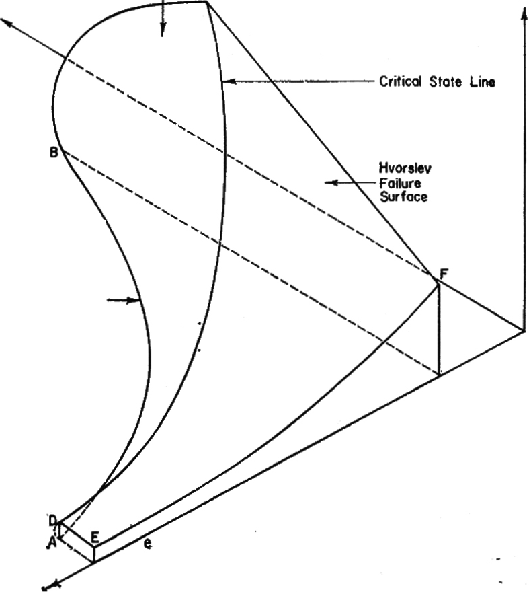

and overconsolidated specimens of Kaolin were presented by JAMES & BALASUBRAMANIAM (1971a and b).

The surfaces ABCD and CDEF are called the state boundary surfaces. It is·difficult to visualise whether the state paths followed by a normally conso lidated specimen lie on the curved surface ABCD. in the three dimensional plot. Therefore, RoscoE & PooRooSHA.SB (1963), devised a method to repre sent the curved surface ABCD by a curve in a two dimensional plot. Sub sequent, workers (see, BuRLAND, 1965) have used alternative parameters such as qfpe, and PIPe for the two-dimensional representation of the state boundary
surface. The parameter Pe is defined as :

Pe=Poexp (eoA-, e)

.................... (!)

where e0, Po correspond to the void ratio and the mean normal stress on the isotropic consolidation line. A. is the slope of the isotropic consolidation line on an (e, logp) plot. Pe is called the mean equivalent pressure and is similar to the preconsolidation pressure defined by HvokSLEV (1937).
'
RoscoE & POOROOSHASB (1963), assumed a unique state boundary surface
in the derivation of the incremental stress-strain theory for normally consoli dated clays. However, the experimental data presented by RoscoE & THuRAI RAJAH (1964), showed that the state boundary surfaces are distinct and dif ferent for undrained and fully drained triaxial tests on normally consolidated

INCREMENTAL STRESS STRAIN THEORY

specimens of Kaolin. Also, the state paths followed during anisotropic con solidation (i.e. consolidation with constant stress ratio) were found to deviate from the state boundary surfaces for undrained and drained test specimens. BALASUBRAMANIAM (1974), made a detailed study of the effects of stress his tory and other factors on the state boundary surface for normally consolidated clays. According to this study, provided the effects of initial one-dimen

sional consolidation stress have not been there, then the state boundary surface is unique and is independent of the applied stress paths.
Figure 2 illustrates the state paths

0.6

0.4

0 0
----i-- 4 'xQ------ -
- 0
I w

followed by three specimens (T AO '
3 ,
rr
and AD) sheared from an isotropic
consolidation pressure of 90 lbjin2. Specimen T3 was sheared under un drained conditions, specimen AO under

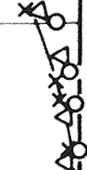
0.2 1----- -----·---r - --
)<ey: j 0
X AO I

constant-p-conditions and specimen AD under fully drained conditions. The state paths followed by all three speci mens are found to be approximately unique.
00..4.:----;:o_ 6-;::::--0-.81.;::---1.0
P /Pe

Fig. 2. State paths followed by three specimens sheared under un drained, constant p and fully drained conditions.

STRESS-STRAIN BEHAVIOR UNDER UNDRAINED CONDITIONS

Undrained tests were carried out on specimens of kaolin one-dimensionally consolidated to 22 lb jin2 and subsequently isotropically consolidated to 30,
60 and 90 lbjin2. The (qjp, E) characteristics of these specimens as shown in
Fig. 3, are found to be unique. These observations are in agreement with those of RoscoE & PooROOSHASB (1963) and hence the shear strain during un drained tests may be expressed as:
r

(o)und<ained = f, (n) dn ......... ... . ....(2)

BALASUBRAMANIAM (1973) has already made a detailed study of the effects of stress history on the stress-strain behaviour of remoulded specimens of Kaolin tested in the conventional triaxial apparatus under stress-controlled conditions. The parameters considered were the initial one-dimensional con solidation pressure used in preparing the samples, the load increment, the magnitude of isotropic consolidation stress prior to shear and the type of applied stress path. These results indicated that the stress-strain behaviour under undrained conditions was unique and independent of the initial one-
19

dimensional stress used during sample preparation. Load increment size and the magnitude of isotropic consolidation pressure prior to shear did not have any effect on the (qjp, c:) relationship for undrained tests.

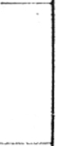
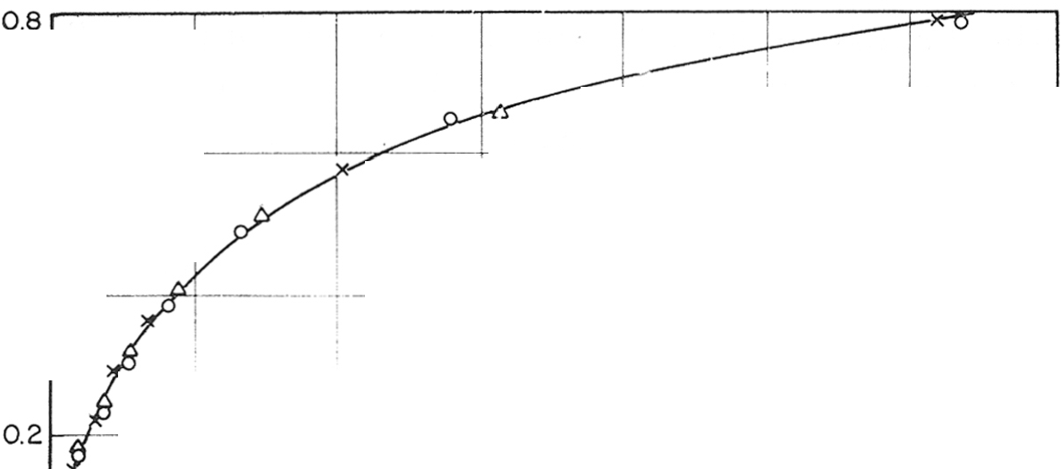
0.
'0-'

0.6
i I
--l- - ----,- --------,
I ,tr ol Isotropic

.Q
a0:: X
Test designation
I

rl.
22
60
lr .. .
I - 0 stress,psi stress,psi

IJ) IJ)
...
4>
0.4
6X--fr)-(--<:):(. T: · - 22 30

ij)
i
I
o----o---o T31
----2+2 --- 90

! -- ----·--- -- I
. I

Ir
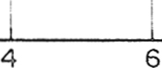

ij'"'" _

i i I I

I
0
2 8 10 12 14
Shear Strain, €,%

Fig. 3. (q/ p, c) relationship for specimens sheared under undrained condition.

ANISOTROPIC CONSOLIDATION

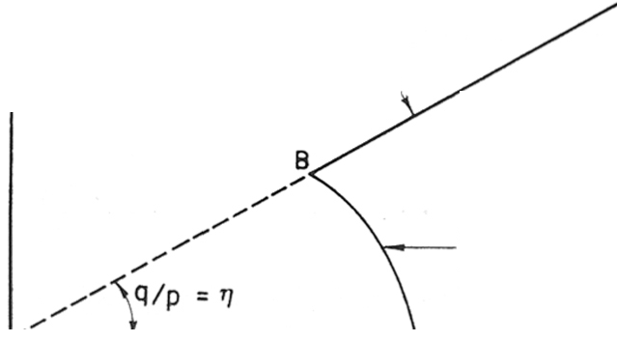
During anisotropic consolidation, the stress ratio, cr / /cr 3' is maintained constant (cr/ is the major principal stress and cr3' is the minor principal q stress). Figure 4 illustrates a possible experimental procedure for such a test
in the ( q ,p ) plot. A specin1en is sheared under undrained condition from the

Anisotropic
Consolidation
Path \

I
8

Undrained
Stress Path
normally consolidated state under a cell pressure Po corresponding to point A. The undrained stress path is denot ed by AB. From B, the specin1en is subjected to anisotropic consolidation along the path BB'. During anisotropic
consolidation q jp (= 11) is maintained

"'-----'- - - - --'A'-----p

Fig. 4. Anisotropic consolidation path.
constant :

(k - 1)
11 = 3 (k + 1)

.. .... . ....... . .. . ....... (3)

where
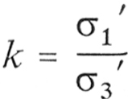

............................. (4)

INCREMENTAL STRESS STRAIN THEORY

Figure 5 illustrates the state boundary surface for normally consolidated clays i11 the (p, q, e) space. In this figure the curve AA' corresponds to isotro pic consolidation, while the curves BB', CC'; etc. correspond to anisotropic consolidation. ABCD, A'B'C'D' are constant voh!me (or undrained stress) paths. In this figure be' corresponds to a fully drained stress path with constant cell pressure. It is split into two parts viz. be, an undrained stress path and cc', an anisotropic consolidation path.

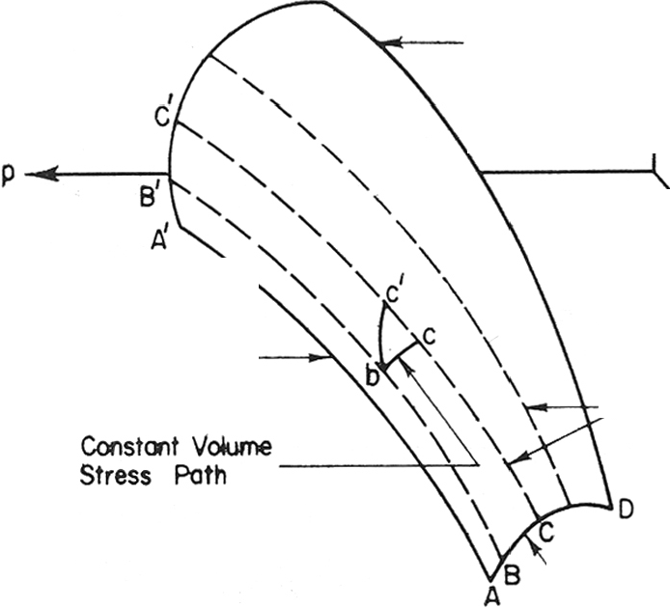
q

o'

Critical State
Line

Isotropic
Consolidation -----.
Line Anisotropic
.---\--:r- Consolidation
Lines

'-----Undrained e
Stress Path

Fig. 5. Isometric view of the state boundary surface for normally consolidated clay.

Experimental Observations on Anisotropic Consolidation Tests

Altogether five anisotropic consolidation tests were performed on speci mens initially one-dimensionally consolidated to 22 lb/in2, and subsequently isotropically consolidated to 90 lbjin2. They were then sheared either under undrained condition or under constant dqjdp condition to the required stress ratios. The tests were designated by BF, BC, BT, BLand T10, and they cor responded to qjp (= 11)-values of0.205, 0.405, 0.51 , 0.57, and 0.71 respective ly. The strain paths followed by these specimens in the (v, c) space are shown in Fig. 6, where the strain paths are found to be linear. These results confirm the original findings of RoscoE & PooROOSHASB (1963), i.e. that (dv/dc)11
during anisotropic consolidation is only dependent on the value of 11· The
values of (dvjd c)11 observed for the five tests are 2.80, 1.30, 1.00, 0.775 and
0.45. These values correspond to q jp (= 11)-values of0.205, 0.405, 0.51, 0.57
and 0.71 respectively. Figure 7 illustrates the variation of (dv/d c)11 with 11
21
A.S. BALASUBRAMANIAM

for all the five tests conducted. It can be seen that (dv jd e)11 varies uniformly with 11 and may expressed as :

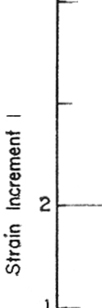
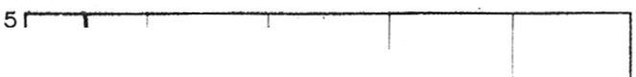
(dvjd e)11 = f2 (11)

(5)

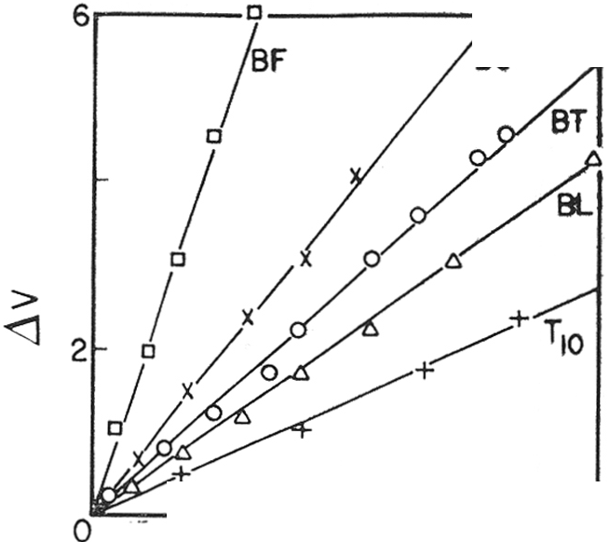
I I
i
\ , I I

8C -r.:,'4
-··-\- ! Test OesionoUbn
: !
!

> \ I I C> 8F
0 \ ! • o ec
4 3 -··-- -\!---------·-- ----- X BT ---·
I
'1.. ! 0 BL
0 I \ : + T10

__L_\
_;_
_ ! _ _j
- ---

2 4 6
.12 %

Fig. 6. Strain paths followed by specimens during anisotropic consolidation.
1 '\ i I .

--·t---··:-- x, ---·-+-······-
: I .
'-+. I
' -....1.

Stress Rotio, q/p

Fig. 7. Relationship between strain incre
ment ratio and stress ratio.

The changes in void ratio with the logarithm of the mean normal stress during anisotropic consolidation on two specimens (at 11 values of 0.405, and 0.57) are shown in Fig. 8. The variation in e with log pis found to be linear and
the slopes (equals to 0.26 approximately) of these lines are the same as that of

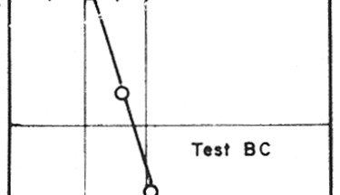
1.24
Mean Normal Stress,p, lb/ir- 2
60 80 100 200

Mean Nonnol Stress,p,lb/in 2
100 150 200
1.15

1.20
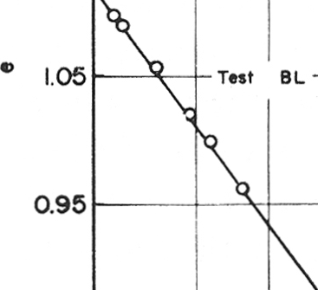

.e .
0 .2
a: 1.16
--o -c

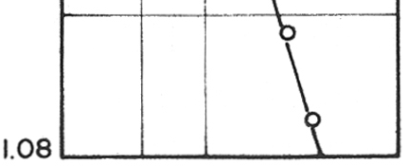
1.12

0.85L-----'---'----'

1\ = o.•
>. .. 0.
1'\. " 0.57

Fig. 8. (e, log p) relationship during anisotropic consolidation.

the isotropic consolidation line in an (e, logp) plot. by A. Then, during anisotropic consolidation:
e- ec = -A logp fpc

Let this slope be denoted

(6)

where ec, Pc corresponds to any known void ratio and pressure on the aniso tropic consolidation line. The stress and state paths followed by two speci mens during anisotropic consolidation are shown in Fig. 9. It is noted that the state paths during anisotropic consolidation do lie on the state boun dary surface. These results are in agreement with the assun1ptions made by RoscoE and PooROOSHASB in their incremental stress-strain theory.

.......
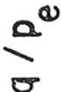

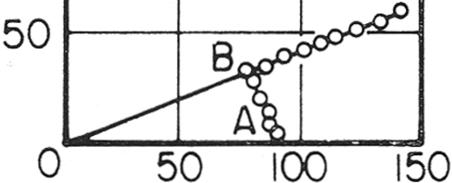
150 ---.,...--..,..---

IOOr------+---

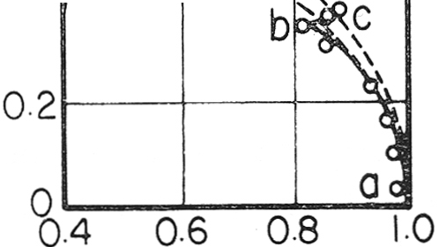
o. 6r--- ---,..----,
-- '

.............
0.4t----t- -- ."...'-.:t-> ----1

.0 c

Stress Path p, lbi;n 2

(a)

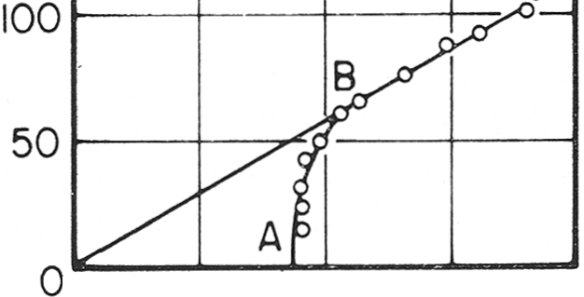
150 ---..,..-- ---,.----,

Co

50 100 150 200

2
Stress Path p , lb/ in

State Path p 1 Pe

Specimen BC

0. 6
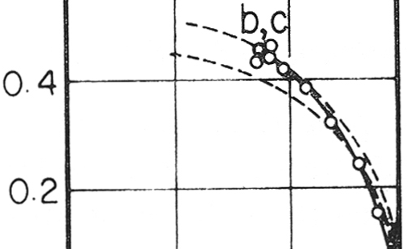

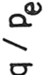

a
0 '---"""-----"""--
0.4 0.6 0.8 1.0

State Path p /Pe

( b) Specimen BL

Fig. 9. Stress and state paths followed during anisotropic consolidation.

INCREMENTAL STRESS-STRAIN THEORY OF ROSCOE AND POOROOSHASB

Assuming a unique (p, q, e) surface, an incremental stress-strain theory was proposed by RoscoE & PooROOSHASB (1963) of the form :
23

d £ 1 = (de) d11 + (d

8
) dv .......... (7)

d11 v dv 11
where (d etfd11)v corresponds to the variation of £ 1 with 11 in an undrained test, and (d e 1/dv)11 represents the variation of £ 1 with v in a constant-11 (ani sotropic consolidation)-stress path. dv and d £ 1 are the incremental volumet ric and axial strains.
The incremental stress-strain theory of RoscoE and PooROOSHASB in Eq. 7 will now be presented in a slightly different form as follows :

d 8 = (d

8
) d11 + (d

8
) d v .. .. .. .. .. (8)

d11 v dv v
where instead of using the incremental axial strain d e1, the incremental shear strain de will be used. Equation 8 can be expressed in the form :

d £ = f1

(11) d11 +
1
-
f2 (11)

dv . .. . .. .. .. .. (9)

where f 1(11) d11 has been shown to be equal to the incremental shear strain in an undrained test (Eq. 2, and f2 (11) is equal to (dvjde)11• Therefore, the total shear strain in any type of test can be obtained .by integrating Eq. 9.
Thus:

e = I n f1

(11) d11 +
In 1

dv .. .. .... .. . . (10)

0 0 f2 (11)
-

Determination of Volumetric and Shear Strains

The procedure adopted for calculating the volumetric strain along any applied stress path is as follows. Let AB in Fig. 10 be the applied stress path for which the volumetric strain-stress ratio relationship is being determined. Then the undrained stress path AC through the point A is drawn assuming that the state boundary surface is unique (since intersections of the state boundary surface by planes of constant void ratios are similar curves). The path AB is divided into a large number of small steps, AB1, B1B2 , B2 B3 .•.•
BnB. Then each step AB1 is considered in two parts; AC1, along an
undrained stress path and C1B1, along an anisotropic consolidation path
(stress ratio 11 1). The volumetric strain experienced by the specimen at

states, B1, B2 •• .•Bn, B is denoted by vB 1
,
vB . . . .. vB, and the incremental
2

volumetric strain for the steps AB , B B ..... Bn B by dvAB , dvB B .....
1 1 2
1 1 2
dvB B· Similar notation is used for the shear strain, i.e. eB , eB ..... eB
n 1 2
denotes the shear strain at states B1, B2 . • ..Bn. The incremental shear strain
for the steps AB , B B . . ..BnB is d eAB , d eA B ... . deB B· The notation
1 1 2
1 1 2 n
24

q

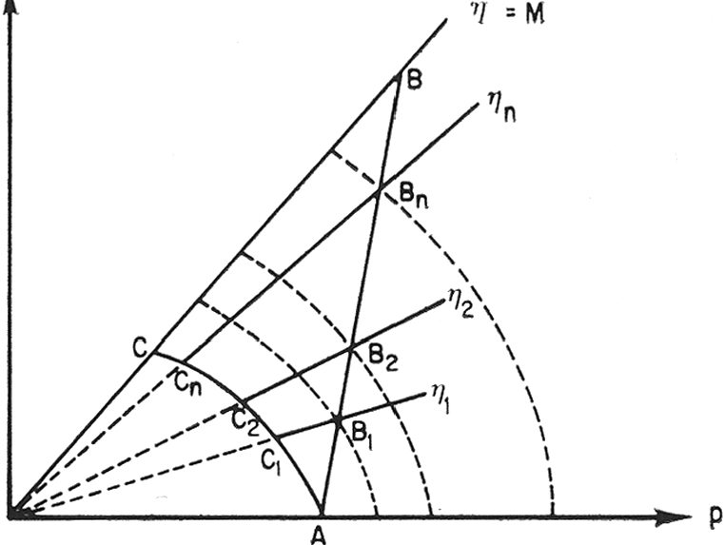

e
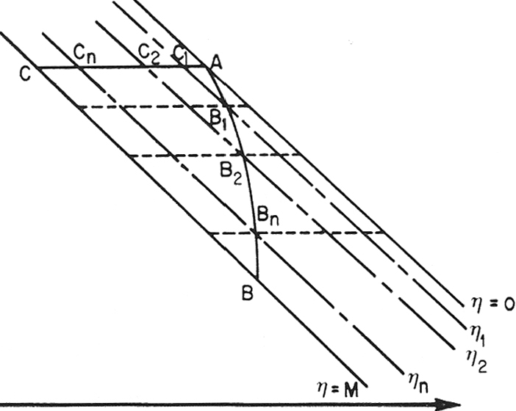

log p.

Fig. 10. Incremental steps in the calculation of volumetric and shear strains in drained test.

for the shear strains along the undrained stress path AC for the states C1, C2 ..... Cn is Ec , Ec ..... Ec and for the incremental shear strains for
1 2 3
the steps, AC1, c1 c2 ..... cnc is d EAc ' dEc c .. ... dEc c·
1 1 2 n
Assuming a unique state boundary surface, it can be shown that :

and since:

dvAB dvAC + dvc B
=
1 1 1 1

dvAC = 0
1
dvAB = dvc B
1 1 1

(11)

. . . . . . . . . . . . . . (12)

Let ( e0 , p 0) be the void ratio and the mean normal stress at point A on the isotropic consolidation line. Then the isotropic consolidation line can be expressed as :
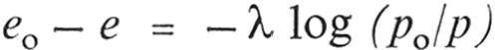 (13)
25

If Pc PB
1 1
denote the mean normal stress for states C1 and B1 and if eB 1 is

the void ratio corresponding to the state B1, then :
e - eB = -A log (Pc IPs ) ....... . .. . .
0
1 1 1

(14)

Also:

vB =dvc B =dvAB =log(- 1 +eo) ··· ·····
1 1 1 1 1 +e
B1

(15)

Hence, knowjng e , A, Pc and PB , eB can be evaluated and therefore vB ,
0
1 1 1 1

dvc s
, dvAB
may be determined.

1 1 1
Similarly, considering the state points C2 , B2 :
eo- eB =-A log (Pc / pB ) · · ·· · · · · · · ·· (16)
2 2 2

and

VB =

1Og

1 + eo )
(

(17)

2 1 + eB2
Thus, from Eqs. 16, 17 vB can be evaluated. Then :
2
dvB B = VB -VB
1 - 2 2 1

(18)

The same procedure can be repeated to determine vB , vB .... vB and also
3 4 n
d vB B , d vB B . . . . . d vB B. Hence, the volumetric strain stress ratio
2 3 3 4 n
relationship can be established.
The procedure adopted for determining the shear strain-stress ratio rela
tionship will now be described. Using Fig. 3, the shear strain Ec , Ec .... Ec
1 2 n
for stress ratios ll!' lh .... 11n can be obtained for points c1' c2 . . ..en.
Similarly, using Fig. 7, the values of f2 (11) can be estimated for the paths with stress ratios 111, 11 2 .. .. 11n.
Hence:

EB1
= Ec1
+ f2 (111) dvA1 B2
·· · · · · · · · · (19)

EB = Ec
2 2
+ f2 (111) d vA B + f2 (112) dvB B ·· · · · · (20)
1 1 2

and c:B = Ec + l: f2 (11) dv ... .... ....... (21)
Thus, the shear strain-stress ratio relationship may be obtained. The above calculations of the volumetric and shear strains are carried out by using a com puter and taking increments of stress ratio of 0.01 for all applied stress paths discussed in the subsequent section. Any further reduction in the stress ratio did not have any appreciable effect on the magnitude of the strains.

COMPARISON OF OBSERVED AND PREDICTED STRAINS FOR A VARIETY OF STRESS PATHS

Constant Mean Normal Stress Path

A constant mean normal stress test was carried out starting at 90 lbjin2
isotropic stress. During this test, the axial stress and the cell pressure were
26

90

(\j
c
so . .

c:
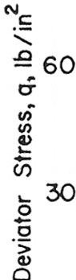

 |  | ore_----- P | -
I I I
:------ --- ---

0 Test AO
l
9
9' ttredicted _
!
-

'. 60
u
1/)
1/)
----- -----

Q.--
0/...
-c-l--_......
---

en 3o
....
0
0
-
a
q..-,9 LPredicted
,"
I
(Y
I
0 Test lAO
I

0 2 4 6 8 0
Volumetric Strain, v ,%

5 10 15 20
Shear · Strain, € , %

Fig. 11. Observed and predicted stress-strain relationships for constant p test.

adjusted, in such a way that the mean normal stress p remained constant. The state path followed by this specimen can be viewed in the ( q fpe, PIPe) plot, which has""already been presented in Fig. 2. The (q, c:) and the (q, v ) charac teristics for this specimen are shown in Fig. 11. In this figure, the experimen tal points are shown as circles and the predictions from the theory by the dotted curve. Excellent agreement between experimental and predicted
strains can be observed.

Fully Drained Stress Path
90 ,.---,----- --, ,--- - ,- .................

"'c : I - --/

sor-
I I -r--t-..-..-

----

A fully drained test with constant
---1-----+-
1 _.,9,/ 1

cell pressure was performed starting · P... --P redicr ed I
from 90 1b/in2 isotropic stress con- . 3o r- .J. _...... · ! o rest Ao -
dition. The state path followed by 0,9"9' / 1 :i jI
' ,

this specimen in the ( q fqe,PIPe) plot,
has already been shown in Fig. 2.
T i I
0 ---2 ----4---

------
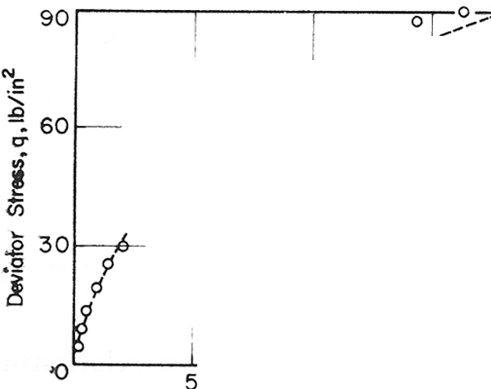
s a 10

The (q, c:) and the(q, v) relationships for this specimen are shown in Fig.
12. In this figure, the experimental points are plotted as circles and the .predictions from the theory are indicated by the dotted curve. Again good agreement is noticed between experimental and predicted strains.

Constant Deviator Stress Path
Volumetric Strain , v, %

, 0,,.,... '
-
;
...
1 o........... j
; ..., · J Predicted - ----·---

;:! )
d I
,6 i
- !---- ·
'

10 1 5 20
Shear Strain, €,%

The stress paths considered so Fig. 12.
far were such that the deviator

Observed and predicted stress-strain relationships for fully drained test with constant cell pressure.

27

A.S. BALASVBRAMANIAM

stress q and also the stress ratio q jp were increasing. For a constant q-stress path,the stress ratio decreases. The stress path followed by a spec imen BX is shown in Fig. 13. In this
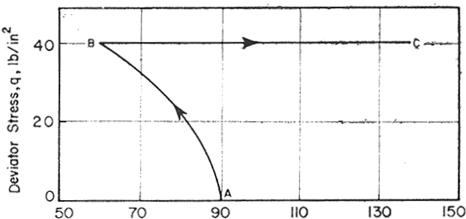

figure, the specimen was initially

Mean Normal Slress ,p,lb 2
/in
sheared along an undrained stress path AB and subsequently the devia

o.a .- -- ---,.-•----.,- -
1
!,..-- --,----,
tor stress q was maintained constant

I I
j I
s 1 I
o.6 -,-·---L------"-· -:-'- ,----1

along path BC, while the mean nor
mal stress p was increased. The

a. o:'I ''0.1............... '
I I'

/ ......'tr-l_fP'@i'Cied I
·-a p . --o---L I
a:: 0.4 '----- --"- - -------- - ==-----!.__ --·-'-.----
observed and the predicted volu
metric strains for the stress path ABC

I I --o---.,L---o----o--c:

0.2 -------- I i I ----1
--t----!------'--
I i
I :
are also shown in Fig. 13. Excellent
agreement is again noted between

·o-----
i
! - 7
i
the two strains. However, for the

3--
Volumetric Stroin , v ,%
s-- 6
stress paths for which the stress ratio

Fig. 13. Constant q test (a) stress path
(b) stress ratio-volumetric strain relationship.
( q jp) decreases, the incremental
stress-strain theory of RoscoE &
PooROOSHASB cannot be used for the

prediction of shear strains. For such paths, the incremental stress-strain theory could perhaps be modified by neglecting the undrained component of the shear strain on the right hand side of Eq. 8. This would lead to the
expression for shear strain as :

d £ = ( ) . dv. dv 11
(22)

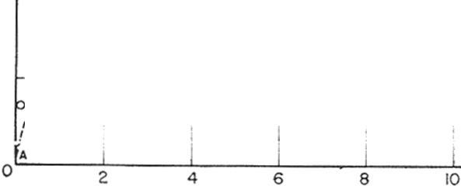
In Eq. 22, it is assun1ed that the value

1 Q --.,. , i ,
0.61---r---or--"·---r---r,-: --t·----
I ......... Prtdiered
.......j I I ' ,
c:r ..,.,,.·."' . • 0 ' ,,
j / '
0.4 -O,f.... -·-- i_ ;,__ .Q. : ·-·- -··· ' ·-

of (de) which is given by 1/f2 (11), dv 11
when 11 is increasing is also valid

"'
(/)
/ ! ' ! o ! I ' ...,,
,' 0 I '
/ c
o/
0.2 I -- - --- -:· --"·-·--t---:·----f
/ f :
I
!
when 11 is decreasing. The observed
and the predicted strains for the stress paths ABC (shown in Fig. 13) are
shown in Fig. 14, where the prediction

Shear Strain I€ I/o
0
Ia is somewhat more than the actual strains for the phase in which q was

Fig. 14. Stress ratio-shear strain relationship
for constant q test. maintained constant.

Reloading of Specimens with Initial States on the State Boundary Surface

The stress-strain behaviour during subsequent unloading (deviator stress)
28

and reloading (deviator stress) of initially sheared samples with the mean normal stress p increasing all the time will now be considered . The
type of stress path imposed on a

roo

I
I
. --+I -- ---1 I
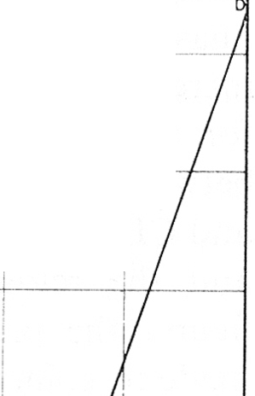

I
I

I
1
I I i

sample,and its previous stress history "' 80 -- --'--·
is shown in Fig. 15. This specimen o-
---f- ---+--
!
1

was initially sheared from the isotro- pic stress state A to the stress state B
l
.g
"' so
iii
-----;------

i
with increasing stress ratio. Subse- -

quently, the specimen was sheared
from B to C along a stress path with
40 1
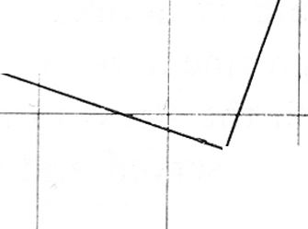
1- - - sf------- :---t--- H- - -l

decreasing deviator stress (q ) and 20
increasing nl.ean normal stress ( p). c

This second phase of shear can be divided into two types, depending on the slope of the applied stress

0 A
07-- 90 ----IIL-------- ----170

Mean Normal Stress, p, lb/in 2

path. In one case, the stress path Fig. 15. Stress path followed by Specimen BP, Showing the phases in which the
BC lies above the downward tangent deviator stress was decreased and then
to the undrained stress path AB at increased.
B. For this case, the point C will lie on the state boundary surface and, therefore, the specimen will be in a normally consolidated state. In the second case, the stress path BC lies below the tangent to the undrained stress path and the point C will lie below the state boundary surface. Only the first

0.4 l A

! I ,//

0 .3 - ---<- - ------- --- --- - --+----- -----+- - - --- ---,L..t-L,
1', I ! /
0. I I

,.."---1------

6- / I '',, I ! 1, // / I

0 I 0 I I ' ........ I I
,<-r- /1. ---- -·----l,,-----i

I / ,

o II
I, v, 1 I /
,i
Predi cted " j
0

0.2 ------- ' - --1 - --------
? i i '
0.1 J._ j_ i------'---.

I i
o-- -- ----j -- -- ----- -- --

Voiumstric Strom • v • %

Fig. 16. Observed and predicted stress ratio-volumetric strain relationship for the specimen subjected to stress path shown in Fig. 15.

A.S. BALASUBRAMANAIM

type of stress path during which the state of the sample always lies on the state boundary surface will be considered for the phase BC. In the third phase of shear (CD), the specimen was subjected to a stress path with increasing stress ratio. The observed and the predicted volumetric strains for the path ABCD are shown in Fig. 16. Excellent agreement is noted between observation and prediction for all three phases of shear, i.e. AB, BC and CD. The shear strain experienced by the specimen during the loading and the reloading phases (i.e. AB and CD) is shown in Fig. 17. In this figure, the predicted and observed values of the shear strains have been made to coincide at point C (which is the start of the reloading phase). This procedure is adopted, since it has already been shown that there is very little agreement between observed and predicted shear strain for the phase in which the stress ratio is decreasing. Good agreement.is noted, however, between observed and predicted shear strains for the reloading phase CD.

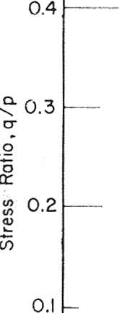
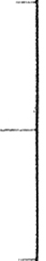
0.5 ,-----,..----r---.---r----.---,L -:;:: >--o·-1.---,
D

I 1 ./o1
I / --/
·--;----- ;- . ---·------ l p--" -'----- -- . -----··;--- -----

' !I .-"--·r .
I ./ 0 ' / I .

PrediCTed 7"-----1-,---- ,,1 ' --
.
Pre--d1e-ted...... - .... ---- --·-·-- ---

.2 _/r · / : · ·
I J l p I
0
a: -/) -- .... j - t----l--- l --1-----------·!-.. -------+---·--·-
1 ! I I I : i I
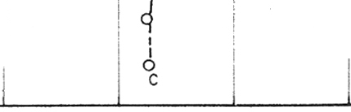
o/ ! ! o,' :

/ : I
/ --!-.. !0 !
I I
6 i
I
I
---,-----i·--t---r-I ·---,---!------

A
·o 2 3 4 5 6 7
Shear Stroin I eI%

Fig. 17. Observed and predicted stress ratio-shear strain relationship for the specimen subjected to stress path shown in Fig. 15.

CONCLUSIONS

A critical reappraisal of the incremental stress-strain theory of RoscoE & PooROOSHASB has been made. From experimental observations and predic tions the following conclusions are reached:

(1) The (qjp, E) characteristics of normally consolidated specimens sheared under undrained conditions are unique and independent of the con solidation pressure.

(2) Provided that the effect of the initial one-dimensional consolidation stress is absent, the state boundary surface is unique for all types of tests on a normally consolidated clay.
(3) During anisotropic consolidation, the strain increment ratio (d vjdc:)11
is a constant.
(4) During anisotropic consolidation, the void ratio varies linearly with the logarithm of the mean normal stress. The slope of the line is the same as the slope 'A of the isotropic consolidation line in an (e, og p) plot.
(5) The state path during anisotropic consolidation lies on the state boun
dary surface.
(6) The volumetric strains in all types of tests may be successfully predict ed from the state boundary surface for normally consolidated clays as obtained from undrained tests (or other types of tests), provided that the states of the sample lie on the state boundary surface.
(7) The shear strain in all types of tests on normally consolidated clays may be predicted from the incremental stress-strain theory of RoscoE
& PooRoos:HASB, provided that the stress paths are such that the stress
ratio always increases or remains constant.

ACKNOWLEDGEMENTS

The experimental work presented in this paper was carried out in the Engi neering Laboratories at the University of Cambridge. The author wishes to thank his supervisor, Dr. R.G. James and the late Prof. K.H. Roscoe for their unstinted help and valuable guidance. The manuscript of this paper was pre pared at the Asian Institute of Technology. Thanks are due to Prof. Za-Chieh Moh, Prof. Edward W. Brand, Dr. Peter Brenner and Mrs. Vatinee Chern.

REFERENCES

BALASUBRAMANIAM, A.S. (1969), Some Factors Influencing the Stress-Strain Beha
viour of Clays, Ph.D. Thesis, Cambridge University, England.
BALASUBRAMANIAM, A.S. (1973), Stress History Effects on Stress-Strain Behaviour of a Saturated Clay, Geotechnical Engineering, Vol. 4, pp. 91-111.
BALASUBRAMANIAM, A.S. (1974), A Critical Study of the Uniqueness of State Bounda
ry Surface for Saturated Specimens of Kaolin, Geotechnical Engineering, Vol. 5, pp.
21-3S.
JAMES, R.G. and BALASUBRAMANIAM, A.S. (1971a), The peak Stress Envelopes and their Relation to the Critical State Line for a Saturated Clay, Proc.4th Asian Regional Conf Soil Mech. Found. Eng., Bangkok, Vol. 1, pp. 115-120.
JAMES, R.G. and BALASUBRAMANIAM, A.S. (1971b), A Comprehensive Experimen tal Study of the Strength Characteristics of Remoulded Specimens of Kaolin, Geo technical Engineering, Vol. 2, pp. 21-33.
A.S. BALASUBRAMANIAM

HVORSLEV, M.J. (1973), Uber die Festigkeitseigenschaften Gestorter Bindiger Boden,
Thesis, lngeniorvidenskabelige, Skrifter, Series A, No. 45.
ROSCOE, K.H. and BURLAND, J.B. (1968), On the Generalised Stress-Strain Behaviour of Wet Clay, Engineering Plasticity, Cambridge University Press, 1968, pp. 535-609. ROSCOE, K.H. and POOROOSHASB, H.B. (1963), A Theoretical and Experimental Study
of Strains in Triaxial Tests on Normally Consolidated Clays, Geotechnique, Vol. 13,
pp. 12-38.
ROSCOE, K.H., SCHOFIELD, A.N. and THURAIRAJAH, A. (1963), Yielding of
Clays in States Water than Critical, Geotechnique, Vol. 13, pp. 211-240.
ROSCOE, K.H., SCHOFIELD, A.N. and WROTH, C.P. (1958), Yielding of Soils. Ceo
technique, Vol. 8, pp. 22-52.
ROSCOE, K.H. and THURAIRAJAH, A. (1964), On the Uniqueness of Yield Surfaces for Wet Clays, Proc. Int. Symp. Rheology and Soil Mech., IUTAM- Grenoble, pp.
364-381.
ROWE, P.W. and BARDEN, L. (1964), The Importance of Free Ends in the Triaxial Tests,
Journal Soil Mech. Found. Div., ASCE, Vol. 90, SM. 1, pp. 1-27.
SCHOFIELD, A.N. and WROTH, C.P. (1968), Critical State Soil Mechanics, McGraw Hill, London.
TING, W.H. (1968), Some Effects of History on the Stress-Strain Behaviour of Kaolin,
Ph.D. Thesis, Cambridge University, England.

APPENDIX : NOTATION

e

eo - f1,fi - k
L Lo p- Po Pe
q-
v-

V

V0 -
voids ratio
voids ratio prior to shear functions
principal effective stress ratio cr / /cr/
current height of sample initial height of sample mean normal stress
mean normal stress prior to shear mean equivalent pressure
deviator stress volumetric strain
current volume of sample
initial volume of sample

cr1', cr2·', cr/- principal effective compressive stress. c:1, c:2 , c:3 - principal compressive strains
€ - shear strain

'A
ll -
slope of isotropic consolidation line in (e, log p) plot
qjp

