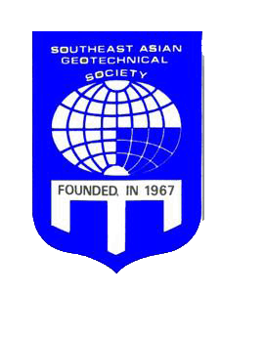

SOUTHEAST ASIAN GEOTECHNICAL SOCIETY (SEAGS)

President: Dr. Ooi Teik Aun Editor-in-Chief of
Secretary-General: Dr. Noppadol Phienwej Geotechnical Engineering Journal: Prof. A.S. Balasubramaniam
Secretariat at Asian Institute of Technology, Km. 42, Paholyothin Highway, Klong Luang, Pathumthani 12120, Thailand SEAGS
c/o A.I.T., P.O. Box 4, Klong Luang, Pathumthani 12120, Thailand  Tel: 66-02-524-5864 Fax: 66-02-524 5865  E-mail: <seags@ait.ac.th>
 Internet: http://www.seags.ait.ac.th

Minutes of the SEAGS

General Membership Meeting on 31 May 2013 at 4:45 PM during the
18th SEAGC/ 1st AGSSEA in Venus III Room of Furama Riverfront Hotel in Singapore

Present: Apologies:

Dr. T.A. Ooi (SEAGS President)
Dr. N. Phienwej (incoming Secretary-General SEAGS)
Prof. D.T. Bergado (outgoing Secretary-General SEAGS)
Dr. Z.C. Moh
Prof. W.H. Ting
Dr. C.T. Chin (Immediate Past President)
Prof. K.Y. Yong
Dr. S.F. Chan
Dr. J.C. Li
Mr. B.K. Tan
Mr. K.S. Yee
Mr. Y.W. Yee
Prof. S.S. Lin
Ir. S.S. Liew
Dr. K.W. Leong
Dr. V. Ong

- The list of proposed Honorary Members of SEAGS as nominated by Prof. Balasubramanian shall be circulated to all GC Members of SEAGS for the purpose of formal election.

- Membership drive in Laos, Cambodia, Myanmar and the Philippines shall be continued.

- The Keynote Lectures in honour of Prof. F.K. Chin, Dr. Z.C. Moh and Prof. S.L Lee will be continued during the next 19 SEAGC/ 2 AGSSEA Conference in Hanoi, Vietnam in 2016.

- Issues of Geotechnical Engineering Journal
  - Restricted access to only SEAGS/AGSSEA members in the current year
  - Four issues per year
  - One issue from each member country
  - Encourage discussions of papers
  - Reimbursement of expenses for the Editor-in-Chief, Prof. A.S. Balasubramaniam.

- Email update of SEAGS/AGSSEA members

- Prof. A.S. Balasubramaniam was nominated and voted as Honorary Member of SEAGS as proposed by Dr. Z.C. Moh and seconded by Prof. K.Y. Yong.

- Mr. Kenny Yee and Mr. Y.W. Yee were designated as official representatives to the Organizing Committee of the 19 SEAGC/2 AGSSEA Conference in 2016.

- The official language is English for 19 SEAGC/ 2 AGSSEA

- Vote of thanks were extended to the organizers of 18 SEAGC/ 1 AGSSEA Conference

